create database sailor;

use sailor;

create table sailors(SID int primary key,SNAME varchar(30),RATING int,AGE int,

check(RATING>=1 and RATING<=10));

create table Boats(BID int primary key,BNAME varchar(20),BCOLOUR varchar(10));

create table Reserves(SID int,BID int,day date,primary key(SID,BID,day),foreign key(SID) references sailors(SID),

foreign key(BID) references Boats(BID));

insert into sailors values(1,'Maneesh',8,21);

insert into sailors values(3,'Kranthi',7,29);

insert into sailors values(2,'Bhargav',5,32);

insert into sailors values(4,'Abhi',9,35);

insert into sailors values(5,'Vineeth',10,27);

insert into sailors values(6,'Sanketh',11,40);

select \* from sailors;

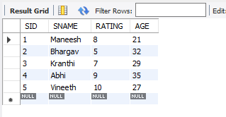

insert into boats values(1,'Keerthi Renuka', 'GREEN');

insert into boats values(3,'Anvika', 'PINK');

insert into boats values(4,'Ishitha', 'BLUE');

insert into boats values(2,'Manasa', 'RED');

insert into boats values(5,'Jyothi', 'ORANGE' );

select \* from boats;

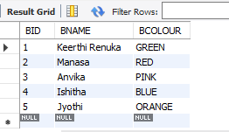

insert into reserves values(1,4,'2018-01-23');

insert into reserves values(2,2, '2018-01-26');

insert into reserves values(2,5,'2018-01-27');

insert into reserves values(3,4,'2018-01-27');

insert into reserves values(5,3, '2018-01-28');

select \* from reserves;

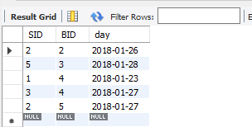

desc sailors;



SELECT S.SID, S.SNAME, S.RATING, S.AGE FROM

SAILORS AS S WHERE S.RATING > 5;

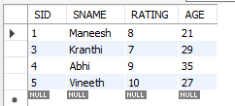

desc boats;

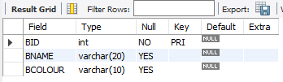

#Any

select \* from boats;

select BCOLOUR from boats

where BID = ANY (select BID from reserves where day='2018-01-27');

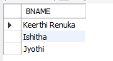

#All

select all BNAME from boats where true;

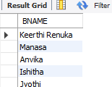

#Exists

select BNAME from boats

where Exists

(select RATING from sailors where sailors.SID = boats.BID and RATING >= 8);



#in

select \* from boats

where BCOLOUR in ('PINK' , 'BLUE');

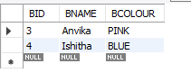

#union

select BNAME from boats union select SNAME from sailors;

